## Appendix A - Description of test areas at Andøya

**RED** = Official Test Area **1**

**Green** = Official Test Area **2**

**Blue** = Official Test Area **3**

## Survey points

**Notice:** Geodetic reference frame is EUREF89.

Differences between EUREF89 and WGS84 (equations from Appendix H):

North: 𝑁 𝑊𝐺𝑆84 𝑒𝑝𝑜𝑐ℎ2025.7 = 𝑁𝐸𝑈𝑅𝐸𝐹89𝑈𝑇𝑀33𝑒𝑝𝑜𝑐ℎ1989.0 + Δ𝑁 where *ΔN=0.652m*

East: 𝐸 𝑊𝐺𝑆84 𝑒𝑝𝑜𝑐ℎ2025.7 = 𝐸𝐸𝑈𝑅𝐸𝐹89𝑈𝑇𝑀33𝑒𝑝𝑜𝑐ℎ1989.0 + Δ𝐸 where *ΔE = 0.472m*

Latitude: 𝜑 𝑊𝐺𝑆84 𝑒𝑝𝑜𝑐ℎ2025.7 = 𝜑𝐸𝑈𝑅𝐸𝐹89𝑈𝑇𝑀33𝑒𝑝𝑜𝑐ℎ1989.0 + Δ𝐿𝑎𝑡 where Δ𝐿𝑎𝑡 =0.000005777°

Longitude: λ 𝑊𝐺𝑆84 𝑒𝑝𝑜𝑐ℎ2025.7 = λ𝐸𝑈𝑅𝐸𝐹89𝑈𝑇𝑀33𝑒𝑝𝑜𝑐ℎ1989.0 + Δ𝐿𝑜𝑛𝑔 where Δ𝐿𝑜𝑛𝑔= 0.000012236

Seven significant decimal digits for latitude and longitude will ensure cm-precision.

Table 1: Coordinates from Jammertest 2025 (Physical height = heights in The Norwegian NN2000 height system)

|  |  |  |  |  |  |  |  |
| --- | --- | --- | --- | --- | --- | --- | --- |
| **Point-ID** | **UTM33-North** | **UTM33-East** | **Physical height** | **Latitude** | **Longitude** | **Ellipsoidal height** | **Mark** |
| FOI | 7686191.493 | 539102.137 | 15.643 | 69.2826137 | 15.9904594 | 51.46 | whip antenna |
| REFANT | 7685369.617 | 538256.263 | 5.424 | 69.2753655 | 15.9687079 | 41.27 | Reference |
| RX-1 | 7685948.751 | 539904.210 | 315.847 | 69.2803196 | 16.0106705 | 351.63 | Antenna FFI |
| RX-2 | 7685779.526 | 540153.947 | 322.206 | 69.2787653 | 16.0169234 | 357.97 | Antenna FFI |
| SAMF | 7685398.515 | 538262.827 | 15.943 | 69.2756237 | 15.9688858 | 51.79 | Lift antenna |
| SENDER | 7685781.138 | 539725.355 | 361.265 | 69.2788432 | 16.0060716 | 397.05 | FFI Jammer |
| SPOOFT | 7685383.702 | 538230.922 | 5.246 | 69.2754954 | 15.9680720 | 41.10 | Antenna rig |
| 11 | 7685387.093 | 538230.784 | 5.134 | 69.2755258 | 15.9680698 | 40.98 | Antenna rig |
| 12 | 7685386.642 | 538229.871 | 5.057 | 69.2755219 | 15.9680466 | 40.91 | Antenna rig |
| 13 | 7685386.141 | 538229.009 | 5.049 | 69.2755175 | 15.9680246 | 40.90 | Antenna rig |
| 14 | 7685385.635 | 538228.140 | 5.036 | 69.2755131 | 15.9680024 | 40.89 | Antenna rig |
| 21 | 7685386.252 | 538231.246 | 5.062 | 69.2755182 | 15.9680814 | 40.91 | Antenna rig |
| 22 | 7685385.758 | 538230.377 | 5.068 | 69.2755139 | 15.9680592 | 40.92 | Antenna rig |
| 23 | 7685385.266 | 538229.503 | 5.054 | 69.2755097 | 15.9680367 | 40.90 | Antenna rig |
| 24 | 7685384.766 | 538228.630 | 4.980 | 69.2755053 | 15.9680145 | 40.89 | Antenna rig |
| 31 | 7685385.339 | 538231.770 | 5.209 | 69.2755100 | 15.9680942 | 41.06 | Antenna rig |
| 32 | 7685384.878 | 538230.890 | 5.039 | 69.2755060 | 15.9680717 | 40.89 | Antenna rig |
| 33 | 7685384.382 | 538230.015 | 5.057 | 69.2755016 | 15.9680495 | 40.91 | Antenna rig |
| 34 | 7685383.883 | 538229.164 | 5.052 | 69.2754973 | 15.9680275 | 40.90 | Antenna rig |
| 41 | 7685384.546 | 538232.232 | 5.064 | 69.2755028 | 15.9681055 | 40.91 | Antenna rig |
| 42 | 7685384.042 | 538231.360 | 5.050 | 69.2754984 | 15.9680833 | 40.90 | Antenna rig |
| 43 | 7685383.547 | 538230.499 | 5.048 | 69.2754941 | 15.9680613 | 40.90 | Antenna rig |
| 44 | 7685383.040 | 538229.633 | 5.044 | 69.2754897 | 15.9680391 | 40.89 | Antenna rig |
| B-L2 | 7685391.362 | 538263.503 | 6.734 | 69.2755595 | 15.9688999 | 42.58 | Ericsson Bleik |
| B-L4 | 7685391.773 | 538264.495 | 6.705 | 69.2755630 | 15.9689251 | 42.55 | Ericsson Bleik |
| B-R2 | 7685392.352 | 538263.080 | 6.719 | 69.2755684 | 15.9688897 | 42.57 | Ericsson Bleik |
| B-R6 | 7685393.160 | 538264.947 | 6.694 | 69.2755754 | 15.9689374 | 42.54 | Ericsson Bleik |
| A50 | 7679501.865 | 536949.186 | 29.738 | 69.2229328 | 15.9333533 | 65.62 | Tree stick top |
| A100 | 7679550.533 | 536960.850 | 29.818 | 69.2233676 | 15.9336665 | 65.70 | Tree stick top |
| A150 | 7679599.058 | 536972.552 | 29.739 | 69.2238011 | 15.9339807 | 65.62 | Tree stick top |
| B50 | 7679418.905 | 536973.788 | 30.131 | 69.2221856 | 15.9339426 | 66.02 | Tree stick top |
| B100 | 7679384.449 | 537010.067 | 30.997 | 69.2218716 | 15.9348456 | 66.88 | Tree stick top |
| B150 | 7679350.055 | 537046.308 | 32.009 | 69.2215582 | 15.9357476 | 67.89 | Tree stick top |
| LOK2-ORIG | 7679453.277 | 536937.520 | 31.037 | 69.2224987 | 15.9330398 | 66.92 | Tree stick top |
| C50 | 7679439.113 | 536889.548 | 28.525 | 69.2223782 | 15.9318229 | 64.41 | Tree stick top |
| C100 | 7679424.877 | 536841.664 | 28.187 | 69.2222571 | 15.9306079 | 64.08 | Tree stick top |
| C150 | 7679410.700 | 536793.771 | 27.856 | 69.2221365 | 15.9293930 | 63.75 | Tree stick top |
| D50 | 7679467.432 | 536985.437 | 30.981 | 69.2226191 | 15.9342555 | 66.87 | Tree stick top |
| D100 | 7679481.647 | 537033.357 | 30.896 | 69.2227400 | 15.9354713 | 66.78 | Tree stick top |
| D150 | 7679495.848 | 537081.292 | 34.431 | 69.2228608 | 15.9366873 | 70.31 | Tree stick top |
| E50 | 7679404.753 | 536925.903 | 29.761 | 69.2220652 | 15.9327277 | 65.65 | Tree stick top |
| E100 | 7679356.100 | 536914.217 | 28.025 | 69.2216305 | 15.9324140 | 63.91 | Tree stick top |
| E150 | 7679307.500 | 536902.524 | 29.144 | 69.2211963 | 15.9320999 | 65.03 | Tree stick top |
| F50 | 7679502.204 | 536889.820 | 28.597 | 69.2229439 | 15.9318539 | 64.49 | Tree stick top |
| F100 | 7679529.409 | 536847.921 | 28.102 | 69.2231936 | 15.9308061 | 63.99 | Tree stick top |
| F150 | 7679556.671 | 536805.978 | 27.602 | 69.2234437 | 15.9297573 | 63.50 | Tree stick top |
| 301 | 7670668.615 | 530198.748 | 8.408 | 69.1445606 | 15.7600883 | 44.52 | Painted mark |
| 302 | 7670680.369 | 530212.300 | 8.494 | 69.1446644 | 15.7604330 | 44.61 | Painted mark |
| 303 | 7677529.277 | 534164.531 | 8.165 | 69.2056106 | 15.8623208 | 44.16 | Painted mark |
| 304 | 7677547.576 | 534161.777 | 8.091 | 69.2057751 | 15.8622579 | 44.08 | Painted mark |
| 305 | 7678210.998 | 534007.445 | 6.021 | 69.2117434 | 15.8585974 | 42.02 | Painted mark |
| 306 | 7678203.811 | 534010.272 | 6.108 | 69.2116786 | 15.8586663 | 42.10 | Painted mark |
| JAM-S3 | 7678284.284 | 533996.471 | 7.472 | 69.2124019 | 15.8583464 | 43.47 | Jammer site 3 |

## Description of Test Area 1

Overview of survey points

Et bilde som inneholder tekst, kart

KI-generert innhold kan være feil.

Et bilde som inneholder skjermbilde, diagram, kart

KI-generert innhold kan være feil.

More detailed view of surveyed points outside Bleik samfunnshus.

## Description of Test Area 2

Test Area 2 is the parking lot at the end of a dirt road. (Position N 69.2225°, Ø 15.9335°)

Most of the testing will be conducted at the parking lot, or the surrounding area.

The setup is based around known positions, distances and controlled RF power levels

for the tests.

Et bilde som inneholder tekst, skjermbilde, kart

KI-generert innhold kan være feil.

Test Area 2, directions for where we place the jammers and several new directions (2025) that will work as visual markers from the air as “drone waypoints”.

**The test setup at location 2**

A, B and C axis are positions used for placement of jammers, or spoofing equipment, as shown in figure 1. A, B and C axis is separated 120 degrees apart will be marked with “wood sticks” (trelekter).

D and E axis are continuations of C and A axis. They will be marked wit drone waypoints visual from the air. The F axis is approximately 5m perpendicular to the edge of the road coming into Test Area 2. The purpose of the F - markers is to make drone landing platforms available for attendees.

D, E and F- axis will have this black and white drone markers, which should be visible at 100 meters above ground level.

Distances from LOK2-ORIG to drone platform markers along the F-axis:

LOK2-ORIG – F50: *68.36m*

LOK2-ORIG – F100: *117.62m*

LOK2-ORIG – F100: *167.38m*

Example: drone marker/ visual waypoint. (Dimensions 50 cm x 50 cm)

Et bilde som inneholder line

KI-generert innhold kan være feil.

Fiducial marks added to drone markers for Test Area 2.

Axis marked with color and distance marked with squares.

Red = D - direction

Blue = E - direction

Green = F - direction

1 square = 50 meters

2 squares = 100 meters

3 squares = 150 meters

4 squares = 200 meters

Et bilde som inneholder Grafikk, triangel, line, design

KI-generert innhold kan være feil.Example: D – direction @ 150 meters.

## Description of motorcade route(s) on Andøya, Test Area 3

The start is as Stave community house (69.212187 North ,15.858559 East), the small jammers can be used the intersection between county road 7702 and communal road “Oklveien” (69.14409 North, 15.75847 East). The figure below shows the stretch that can be used for the motorcade (Red line).

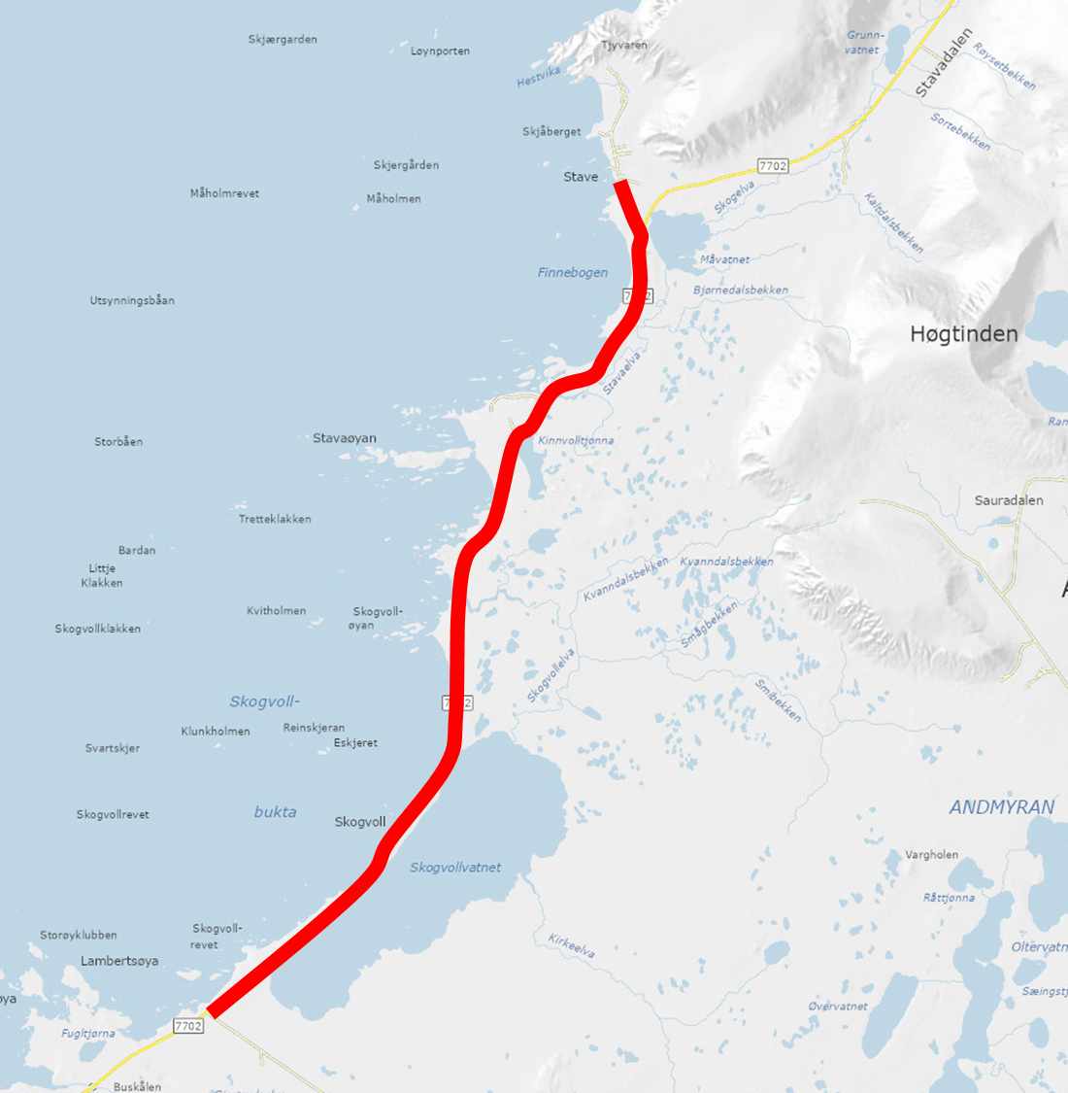

The road is quite narrow 5.1 meters with a speed limit of 80 km/h. The traffic volume is low with about 1000 vehicles per day. For some tests where reduced speed is need there will be a NPRA vehicle in front and at the back of motorcade. Communication to the vehicles will be via FM radio.

**Calibration Control Marks** (New at Jammertest 2025)  
In a straight, open road section, three pairs of control marks (301-306) will be painted in center of the dotted white line at the right-hand side. The marks will be positioned so that vehicles can align with them as follows:

* The **front right wheel** is placed directly on the painted mark.
* The **rear right wheel** is aligned with the center of the white line.

This arrangement provides a precise and repeatable reference for the forward right wheel position relative to the vehicle’s facing direction.

The coordinates of the control marks will be averaged from several time independent RTK-measurements and distributed in *Appendix A* Table 1. These marks are intended for calibrating on-board GNSS and inertial navigation equipment against a known reference point.

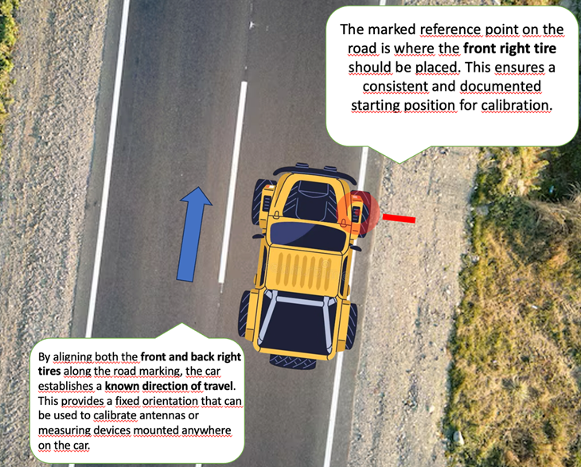

Et bilde som inneholder tekst, kart, atlas, diagram

KI-generert innhold kan være feil.

JAM-S3 is the Jammer-point at the car roof on Site 3

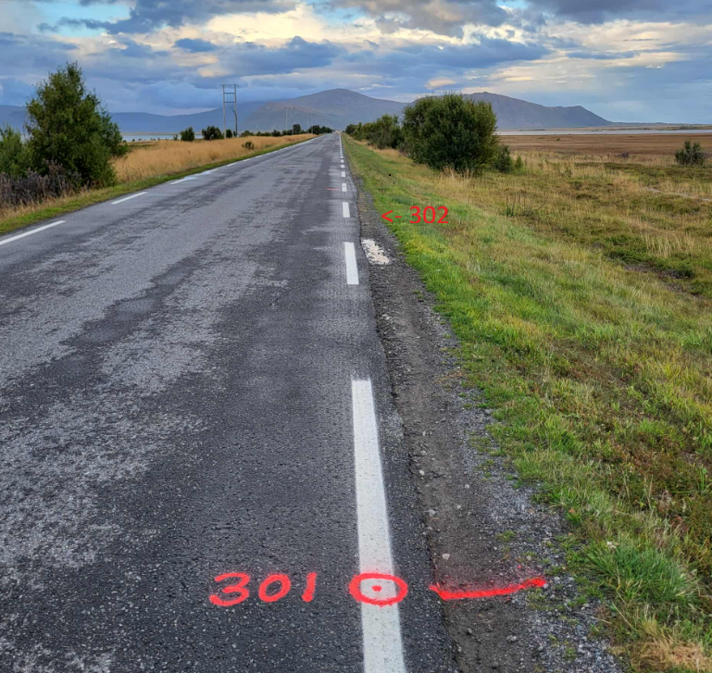Et bilde som inneholder tekst, kart, atlas

KI-generert innhold kan være feil.

Example, one pair of calibration points